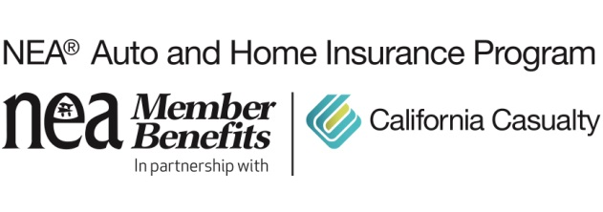
8 Ways to Be a Good Neighbor During Trying Times

Our world has changed seemingly overnight. As we deal with the immediate crisis—and learn behaviors that ensure the safety and well-being of ourselves and others—we all have an opportunity to make our world a kinder and more generous one.

Stay safe, stay home
Across the country, various forms of shelter-in-place and social distancing orders have gone into effect. Stay up-to-date on your state, county, and city’s instructions and follow the orders and advice of local officials. By slowing and limiting the spread of infection, we can “flatten the curve”—protecting vulnerable community members and preventing local hospitals and emergency services from overwhelm.

Check in
For the elderly, immunocompromised or otherwise vulnerable, these are especially scary times. Reach out to those neighbors and friends (on phone, email, through a closed door) and see if there’s anything you can do for them. A grocery run, food pickup or dog walk could make a huge difference. Let them know you’re there for them. If you yourself are in the vulnerable cohort, make it easy for others to know how they can help—there are plenty of people who want to help but don’t know how.

Donate blood
In the midst of coronavirus anxiety, blood drives have been cancelled and donations have dropped. However, maintaining our nation’s blood supply is still critical: Every 2 seconds, a patient needs a blood transfusion. If you’re healthy, consider giving blood. Donation centers are skilled in infection control practices and adhere to strict safety procedures.

Do a virtual food drive
You can deliver needed groceries to families and community members right from your computer. Check the websites of your local food banks, city or city health departments or non-profits that focus on food insecurity. You can sign up as an individual or as a group. For the latter, get creative and launch a drive with friends, family, colleagues or neighbors.

Volunteer
Check with local non-profits, charities or your city for volunteer needs. Many neighborhoods are also forming their own emergency response teams. Volunteers can sign up from a range of activities or projects. If you have the gift of health and security, volunteering is one of the most rewarding ways to pay it forward.

Shop local
Local businesses are hurting, and some may not recover. Patronage right now is more crucial than ever. Place orders online; buy gift cards; keep up your membership. Many restaurants are staying afloat by offering take-out and delivery—if you can afford it, mix up your in-home creations with locally prepared cuisine. And if you can be generous in tipping your delivery drivers, you’ll be helping them through a rough time.

Donate
Public health crises spotlight the gaps in our communities, and this crisis is no different. Many hospitals are in need of gloves, goggles, N95 masks, disinfectant wipes, hand sanitizer, gowns and other PPE. Look through your closets and garage and see if you’ve got extras (new and unused) you can donate to local hospitals. Also check in with your favorite charities, causes or non-profits and see how you can help.

Spread kindness
These are stressful times, and a little kindness goes a long way. For those workers on the front lines (who themselves are at increased risk), receiving some patience, kindness and compassion from customers will buoy their spirits. Be generous where you can. Remember too, that just as with the oxygen mask in the airplane, you can only take care of others after taking care of yourself. So, find ways to make self-care and your own mental health a priority.

California Casualty has been serving the needs of educators since 1951 and is the only auto and home insurance company to earn the trust and endorsement of the National Education Association (NEA). As a result, NEA members qualify for exceptional rates, deductibles waived for vandalism or collisions to your vehicle parked at school, holiday or summer skip payment plans and free Identity Defense protection – exclusive benefits not available to the general public. Learn how to save by getting a quote at www.neamb.com/autohome, or by calling 1.800.800.9410.

