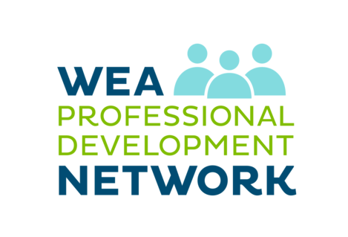

**The Professional Development Network was created and shaped by direct feedback from PreK-12 Classified and Certificated members. The goal is to help you easily find and register for clock-hour trainings in high-demand subjects such as:**

* [**Closing the Achievement and Opportunity Gaps**](https://www.washingtonea.org/closing-gaps/)
* [**Teacher Evaluation**](https://www.washingtonea.org/teacher-evaluation/)
* [**State Learning Standards**](https://www.washingtonea.org/learning-standards/)
* [**Certification: Home Stretch and Jump Start**](https://www.washingtonea.org/certification-licensure/)
* [**Special Education**](https://www.washingtonea.org/training-special-education/)
* [**Advocacy and Organizing**](https://www.washingtonea.org/advocacy-organizing/)

*Visit* [*www.washingtonea.org/pd/*](http://www.washingtonea.org/pd/) *for more information.*